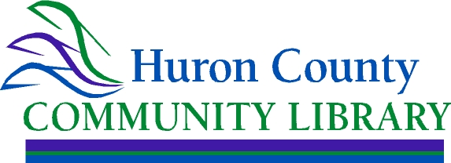

PUBLIC POSTING

The regular, monthly meeting of the Huron County Community Library Board of Trustees scheduled for February 18, 2025 was postponed due to inclement weather.

The Huron County Community Library Board of Trustees have reschedule their February meeting for February 25, 2025 at 9:30 am, at the Willard Memorial Library.

##

Posted February 19, 2025