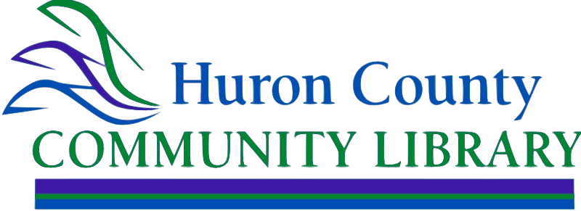

Information Technology – Library Clerk

Willard location

The Huron County Community Library seeks a customer service-oriented individual to join our team, at the Willard location. Information Technology – Library Clerk position is responsible for patron and staff help related to IT. This position calls for the employee to be ready to answer inquiries on mobile devices, PC applications, web based applications, and general technology related issues. In this job, a person would assist Public Services desk as needed, with operating office equipment and Symphony WorkFlows. Follows procedures set by the Library Director, in regard to the Library Board of Trustees policies.

This is a part time position (up to 16 hours per week) that includes paid time off and holiday pay. The compensation is contingent on experience starting at $10.51 per hour.

Qualifications:

High school diploma; experience working with computers; knowledge of electronic applications used in a library environment.

Send a resume and a letter of interest indicating why you are a good candidate for this position to [llwilson@huroncolibr.org](mailto:llwilson@huroncolibr.org) by August 23, 2024.

Position is open until filled. EOE

07292024